**Business Proposal for Installing Data Warehouse**

**Situation**:

Business Stakeholders are currently using data from different database systems like insurance sales systems, claims systems, customer support databases, transactional systems, and many more to analyze and prepare reports which are used by the company executives every quarter for decision making and to manage the track performance of ABC Corp. These data systems are managed by a database administrator, on the request of stakeholders the administrator manually queries the data from all the required database systems. This querying process is time-consuming and slows down the business flow as these queries are performed directly on the data systems serving real-time customers.

**Proposed Solution:**

To avoid these issues a “Data Warehouse” can be used, which stores all the historical, granulated, and summarized data of ABC Corp. This enables users to perform operations like query, extract and analyze to present information in the required format. Data Warehouse acts as a repository where information flows from one or more data sources into one comprehensive database. Structure and unstructured data are transformed and integrated into a data warehouse so that users can directly access this data through Business Intelligence tools, Spreadsheets to run reports systematically for making business decisions.

**Steps involved in installing Data Warehouse:**

Data from all the external data systems will be loaded into the data warehouse (data present in different sources may be structured or unstructured so it is needed to be standardized before loading it). At this stage, the ETL process is followed where data is extracted from all external sources, Transformed into standard form, and then Loaded into the data marts. Data marts are a storage subset of data warehouses, they store information about specific functions like Sales, Marketing, Reinsurance, Finance, and many more. In the next process, these data marts are integrated into data warehouses. From data warehouses, data can be utilized by users to make reports, analyze and forecast.

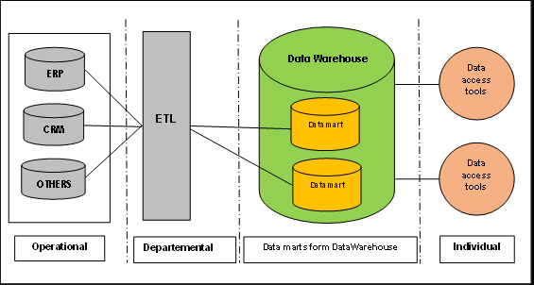

**Benefits:**

Data Warehouse helps business users quickly access critical data from any data system like transactional systems, sales systems, and investments systems all in one place, reducing the time for querying data from every required data source. Users can query the data themselves without relying on it with little to no IT support, saving more time and money. Data warehouse stores huge amounts of historical data. This helps business users analyze various time periods and trends to make better predictions. Sometimes real-time operational databases face downtime which will affect the access to data present in that system and make maintenance of the database expensive to be available all the time, Data Warehouses are not affected by downtime in the system.

**Scheduling:**

There are different time periods for the process of installing a Data Warehouse starting from sketching the design to the launch of the data warehouse. The first 3 to 30 days are dedicated to identifying the organization’s departments, users’ expectations, and requirements for the project such as choosing the optimal cloud deployment options available in the market and finalizing the suitable architectural approach for installing Data Warehouse. For the next 2 to 15 days budget planning, testing activities, and risk management planning must be completed. For the next 15 days, every data system is analyzed for details like daily generated data, missing/incomplete data, and relations to other data systems. Also designing data models for Data Warehouse, data marts, and ETL/ELT (Extract Transfer Load) process for data integration. For the next 2 months, Data Warehouse customizations are performed as suitable to the organization, ETL/ELT pipelines are developed, and performance is tested. Finally, Data is migrated, and Data Warehouse is introduced to the business users. At this stage training sessions and workshops are to be conducted for the users to get adapted to the Data Warehouse system. After the launch of the Data Warehouse, ETL/ELT performance tuning, Data Warehouse performance and availability adjustments, and end-user support as per their requests will be managed. Overall, the estimated time period for the installation Data warehouse is around 4 to 6 months.

**Budget:**

Here are some of the budget estimations considering all the installation processes, firstly depending on the number of data systems, and performance requirements suitable cloud storage Data warehouse for ABC Corp. will cost from $8 to $82 per Tb (Terabyte) per month. ETL/ELT software which is required to perform pipelining and integration of data into the Data Warehouse will cost around $800 to $8000+ per month. A Data Warehouse Project team of Project manager, Backend Developer, Data Analyst, Database Architect, and Administrator will be required to manage and organize all the operations of the data warehouse, managing this team will cost around $38000 per month. As certain areas of business are using spreadsheets for day-to-day tasks it would be not necessary to spend much on visualization tools, this will help us in revenue optimization.

**Conclusion:**

To conclude, a Data Warehouse is a significant investment. However, the returns that will be reaping in terms of business intelligence will be crucial. Data warehouses give more clever, accurate insights of internal operations, letting us make better decisions and lower the overall risk of the organization.

**References:**

<https://www.guru99.com/data-warehousing.html#3>

<https://www.cooladata.com/cost-of-building-a-data-warehouse/>

<https://www.cooladata.com/cost-of-building-a-data-warehouse/>

<https://www.researchgate.net/figure/Kimballs-data-warehouse-architecture-7_fig2_312486486>

<https://www.scnsoft.com/analytics/data-warehouse/building>

<https://www.integrate.io/blog/the-true-cost-of-a-data-warehouse/>